**Title: Martian Atmospheric and Climate Analysis (2012–2018): A Comprehensive Study**

**Author-Sayed Umair Ali**

**Date- 12/07/2024**

**Abstract:** This white paper presents an in-depth analysis of Martian atmospheric and climate patterns between 2012 and 2018 using NASA’s publicly available data. The study evaluates seasonal pressure, temperature variations, and atmospheric opacity, supported by visualizations generated through Python and Plotly. This comprehensive analysis aims to provide valuable insights into Martian meteorology relevant for future exploration and colonization efforts.

**1. Introduction** Mars, Earth’s planetary neighbor, exhibits extreme environmental conditions. Understanding its atmosphere is crucial for future manned missions and autonomous operations. This study aims to quantify and visualize Mars’ atmospheric pressure, temperature fluctuations, and opacity trends over a six-year period. The dataset was preprocessed and visualized using Python with a focus on extracting seasonal trends and long-term patterns.

**2. Methodology**

* **Data Source:** Data was derived from the Mars weather dataset spanning from 2012 to 2018, available in CSV format and cross-referenced with visual observations.
* **Cleaning and Processing:** The dataset was cleaned by removing null values and converting date formats. Atmospheric opacity labels were standardized. A Mars-specific season assignment function was defined using solar longitude (Ls).
* **Visualization Tools:** Plotly was used to generate both time-series and polar plots. Key features included atmospheric pressure, max/min temperatures, and opacity frequency.

**3. Data Overview and Cleaning**

* Dataset contained entries for terrestrial_date, min_temp, max_temp, pressure, ls, and atmo_opacity.
* Null values in critical columns were dropped.
* Solar longitude (Ls) was used to determine seasons:
  + 0° – 90°: Spring
  + 90° – 180°: Summer
  + 180° – 270°: Autumn
  + 270° – 360°: Winter

**4. Atmospheric Opacity Observations**

The majority of observations recorded clear or sunny atmospheric opacity. This suggests that large-scale dust storms or dense atmospheric obscurations are infrequent during the studied period.

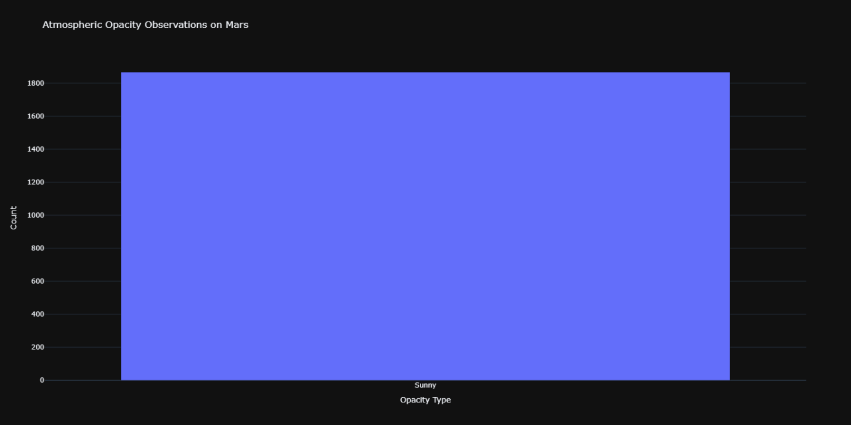

**5. Pressure Analysis**

* **Seasonal Pressure Trends (Polar Plot):** Pressure shows cyclic behavior, peaking around Martian spring and autumn.

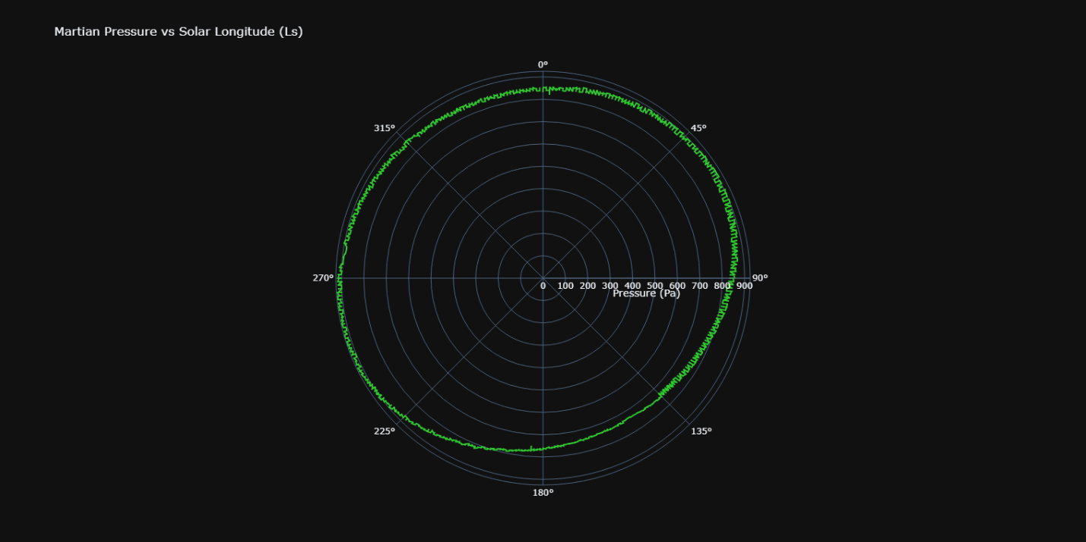

* **Time Series Pressure (2012–2018):** Shows annual pressure cycles. Fluctuations correspond to seasonal CO2 sublimation and deposition at the poles.

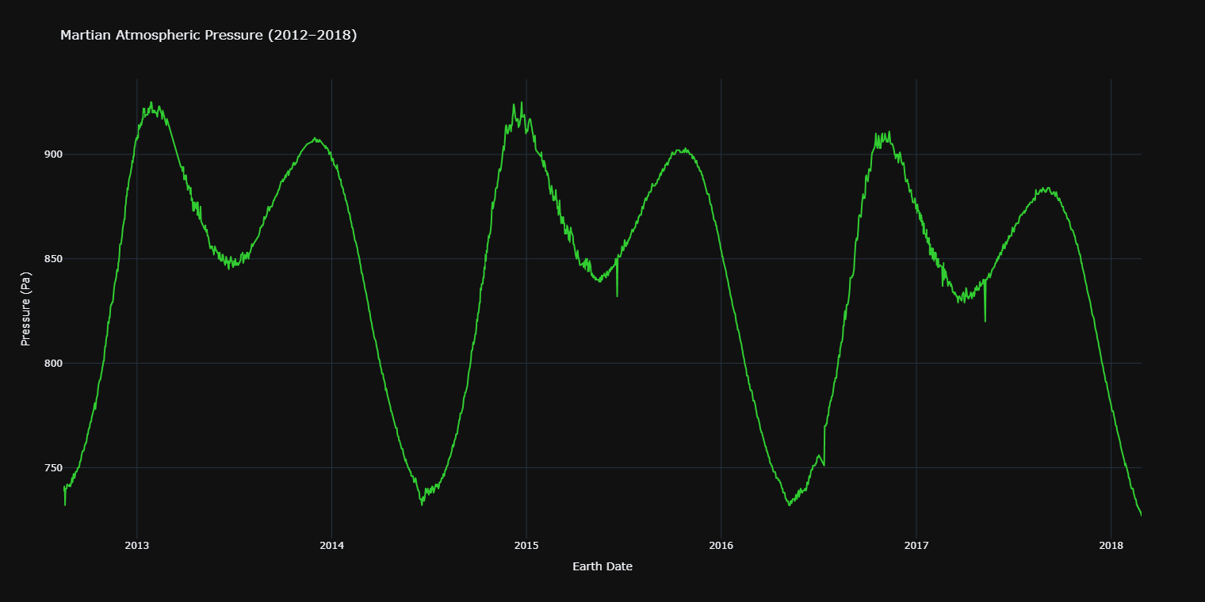

**6. Temperature Analysis**

* **Polar Temperature Plot:** Temperatures oscillate strongly across the Martian year. Max temperatures reach above 0°C while minimums plummet below -80°C.

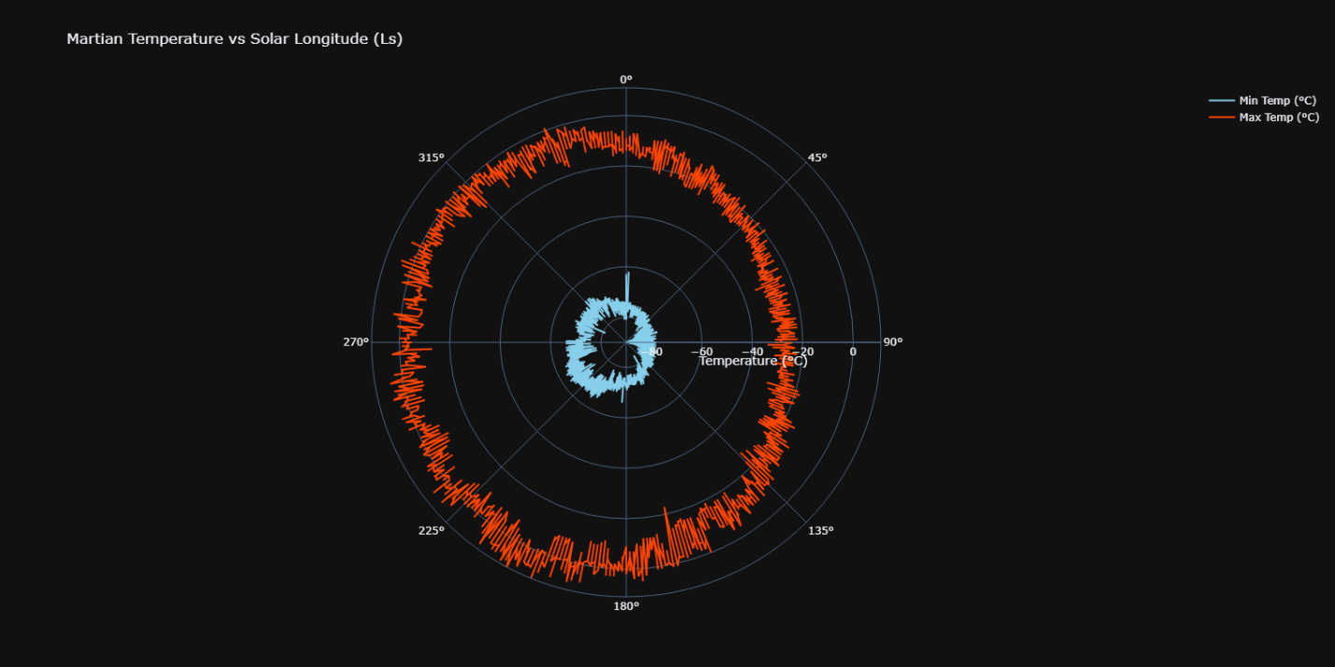

* **Time Series (Min/Max):** Clear cyclic trends emerge with temperature ranges varying distinctly per year.

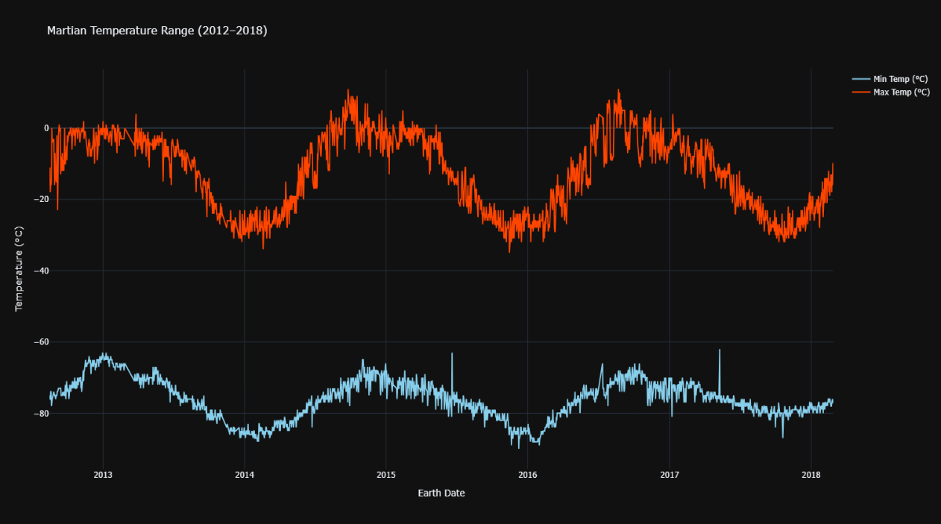

**7. Seasonal Averages**

Using the derived season variable, average min/max temperatures and pressure were computed per season:

* **Spring & Autumn**: Highest atmospheric pressures.
* **Summer**: Highest maximum temperatures.
* **Winter**: Coldest minimum temperatures.

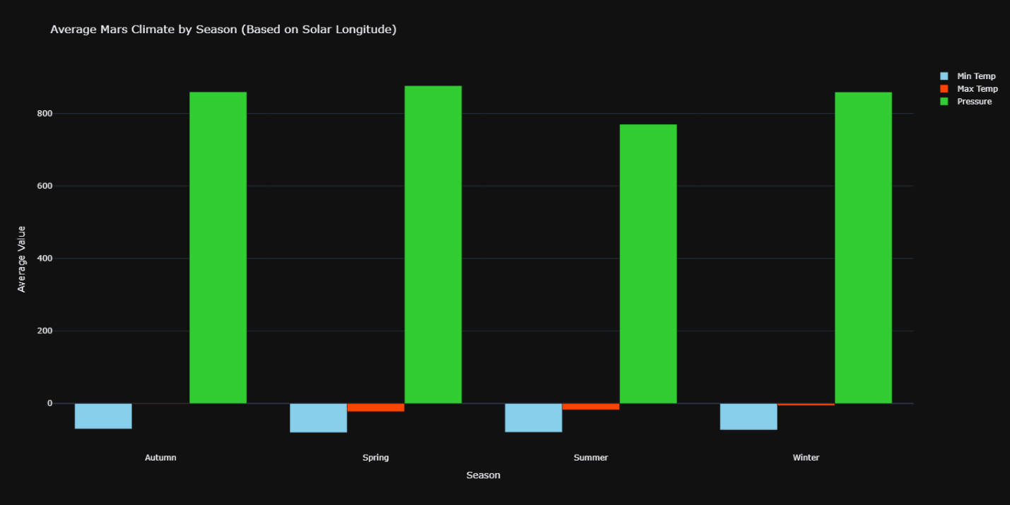

**8. Animated Visualization and python code-**

An animated line graph was produced to depict yearly maximum temperature variation across Earth days for better trend recognition in interactive environments.

*(HTML file: animated_temperature.html not embedded here)*

**8. Conclusion**

This analysis affirms Mars as a planet with dynamic but predictable atmospheric patterns. Pressure cycles closely follow seasonal shifts, while temperature extremes present significant challenges for human habitability. The dominant “sunny” opacity readings suggest a relatively stable visual environment, albeit interrupted occasionally by dust storms. The data and visualizations serve as a foundation for further research into Martian climate modeling, exploration planning, and survival strategy development.

**9. Bibliography**

1. NASA Mars Climate Database. <https://mars.nasa.gov>
2. Martian Weather Data via InSight and Curiosity Missions.
3. Python & Plotly Libraries Documentation.
4. Haberle, R. M., et al. (2017). “The Atmosphere and Climate of Mars.” Cambridge University Press.
5. https://github.com/the-pudding/data/blob/master/mars-weather/mars-weather.csv

**Appendices**

* A. Python Code (main.py) for Data Cleaning and Plotting-

# main.py  
  
import os  
import pandas as pd  
import plotly.graph_objs as go  
import plotly.express as px  
import plotly.offline as pyo  
  
# Ensure offline rendering opens in browser  
pyo.init_notebook_mode(connected=True)  
  
  
def load_and_clean_data(csv_path):  
 if not os.path.exists(csv_path):  
 raise FileNotFoundError(f"❌ Data file not found at: {csv_path}")  
  
 df = pd.read_csv(csv_path)  
 df.columns = df.columns.str.strip().str.lower()  
  
 df = df.rename(columns={'atmo_opacity': 'atmospheric_opacity'})  
 df['terrestrial_date'] = pd.to_datetime(df['terrestrial_date'], errors='coerce')  
 df = df.dropna(subset=['terrestrial_date', 'min_temp', 'max_temp', 'pressure', 'ls'])  
  
 df['season'] = df['ls'].apply(assign_mars_season)  
 df['year'] = df['terrestrial_date'].dt.year  
 df['day'] = df['terrestrial_date'].dt.strftime('%Y-%m-%d')  
  
 return df  
  
  
def assign_mars_season(ls):  
 if 0 <= ls < 90:  
 return 'Spring'  
 elif 90 <= ls < 180:  
 return 'Summer'  
 elif 180 <= ls < 270:  
 return 'Autumn'  
 elif 270 <= ls < 360:  
 return 'Winter'  
 else:  
 return 'Unknown'  
  
  
def plot_temperature(df):  
 fig = go.Figure()  
 fig.add_trace(go.Scatter(  
 x=df['terrestrial_date'], y=df['min_temp'],  
 mode='lines', name='Min Temp (°C)', line=dict(color='skyblue')  
 ))  
 fig.add_trace(go.Scatter(  
 x=df['terrestrial_date'], y=df['max_temp'],  
 mode='lines', name='Max Temp (°C)', line=dict(color='orangered')  
 ))  
 fig.update_layout(  
 title='Martian Temperature Range (2012–2018)',  
 xaxis_title='Earth Date',  
 yaxis_title='Temperature (°C)',  
 hovermode='x unified',  
 template='plotly_dark'  
 )  
 pyo.plot(fig, filename='temperature_plot.html')  
  
  
def plot_pressure(df):  
 fig = px.line(  
 df, x='terrestrial_date', y='pressure',  
 title='Martian Atmospheric Pressure (2012–2018)',  
 labels={'pressure': 'Pressure (Pa)', 'terrestrial_date': 'Earth Date'},  
 template='plotly_dark'  
 )  
 fig.update_traces(line=dict(color='limegreen'))  
 fig.update_layout(hovermode='x unified')  
 pyo.plot(fig, filename='pressure_plot.html')  
  
  
def plot_opacity(df):  
 if 'atmospheric_opacity' in df.columns:  
 opacity_counts = df['atmospheric_opacity'].value_counts().reset_index()  
 opacity_counts.columns = ['Opacity Type', 'Count']  
 fig = px.bar(  
 opacity_counts, x='Opacity Type', y='Count',  
 title='Atmospheric Opacity Observations on Mars',  
 template='plotly_dark',  
 color='Opacity Type'  
 )  
 fig.update_layout(showlegend=False)  
 pyo.plot(fig, filename='opacity_plot.html')  
 else:  
 print("⚠️ No atmospheric_opacity column found.")  
  
  
def plot_season_comparison(df):  
 avg_by_season = df.groupby('season')[['min_temp', 'max_temp', 'pressure']].mean().reset_index()  
 fig = go.Figure()  
 fig.add_trace(go.Bar(name='Min Temp', x=avg_by_season['season'], y=avg_by_season['min_temp'], marker_color='skyblue'))  
 fig.add_trace(go.Bar(name='Max Temp', x=avg_by_season['season'], y=avg_by_season['max_temp'], marker_color='orangered'))  
 fig.add_trace(go.Bar(name='Pressure', x=avg_by_season['season'], y=avg_by_season['pressure'], marker_color='limegreen'))  
  
 fig.update_layout(  
 title='Average Mars Climate by Season (Based on Solar Longitude)',  
 barmode='group',  
 xaxis_title='Season',  
 yaxis_title='Average Value',  
 template='plotly_dark'  
 )  
 pyo.plot(fig, filename='season_comparison.html')  
  
  
def plot_animated_temperature(df):  
 fig = px.line(  
 df, x='day', y='max_temp', animation_frame='year',  
 title='Animated Max Temperature on Mars (Yearly)',  
 labels={'day': 'Earth Day', 'max_temp': 'Max Temp (°C)'},  
 template='plotly_dark'  
 )  
 fig.update_traces(line=dict(color='tomato'))  
 fig.update_layout(xaxis_tickformat='%b %d', xaxis_title='Earth Date', yaxis_title='Max Temp (°C)')  
 pyo.plot(fig, filename='animated_temperature.html')  
  
  
def plot_polar_climate(df):  
 df_sorted = df.sort_values('ls')  
  
 # === Polar Plot: Min/Max Temp vs Ls ===  
 fig1 = go.Figure()  
 fig1.add_trace(go.Scatterpolar(  
 r=df_sorted['min_temp'],  
 theta=df_sorted['ls'],  
 mode='lines',  
 name='Min Temp (°C)',  
 line=dict(color='skyblue')  
 ))  
 fig1.add_trace(go.Scatterpolar(  
 r=df_sorted['max_temp'],  
 theta=df_sorted['ls'],  
 mode='lines',  
 name='Max Temp (°C)',  
 line=dict(color='orangered')  
 ))  
 fig1.update_layout(  
 title='Martian Temperature vs Solar Longitude (Ls)',  
 polar=dict(  
 angularaxis=dict(direction='clockwise', rotation=90),  
 radialaxis=dict(title='Temperature (°C)')  
 ),  
 template='plotly_dark'  
 )  
 pyo.plot(fig1, filename='polar_temperature.html')  
  
 # === Polar Plot: Pressure vs Ls ===  
 fig2 = go.Figure()  
 fig2.add_trace(go.Scatterpolar(  
 r=df_sorted['pressure'],  
 theta=df_sorted['ls'],  
 mode='lines',  
 name='Pressure',  
 line=dict(color='limegreen')  
 ))  
 fig2.update_layout(  
 title='Martian Pressure vs Solar Longitude (Ls)',  
 polar=dict(  
 angularaxis=dict(direction='clockwise', rotation=90),  
 radialaxis=dict(title='Pressure (Pa)')  
 ),  
 template='plotly_dark'  
 )  
 pyo.plot(fig2, filename='polar_pressure.html')  
  
  
def main():  
 base_dir = os.path.dirname(__file__)  
 csv_path = os.path.join(base_dir, "../data/mars-weather.csv")  
  
 try:  
 df = load_and_clean_data(csv_path)  
 plot_temperature(df)  
 plot_pressure(df)  
 plot_opacity(df)  
 plot_season_comparison(df)  
 plot_animated_temperature(df)  
 plot_polar_climate(df)  
 print("✅ All plots generated including polar plots. Check your HTML files.")  
 except Exception as e:  
 print(f"🚨 Error: {e}")  
  
  
if __name__ == "__main__":  
 main()

* B. Data File (mars-weather.xlsx) source- https://github.com/the-pudding/data/blob/master/mars-weather/mars-weather.csv
* C. Additional HTML Files (Interactive Graphs)

**The End**